**Assignment #1: Quantitative Analysis**

**Target:**

* Develop an evaluative research question associated with health care management issues, and propose a methodology that could lead to an improvement of health care delivery.

For this assignment, students should choose **data from the quantitative analysis** below and are  asked to analyze it using **Excel,** RStuido (BONUS points)

**Data set (If you decided to work with RStudio, download data from the class instructions (discussion/class instructions):**

Students will develop an analysis report, in five main sections, including introduction, research method (research questions/objective, data set, research method, and analysis), results, conclusion and health policy recommendations. This is a 5-6 page individual project report.

Here are the main steps for this assignment.

Step 1: Students require to submit the topic using topic selection discussion forum by the end of week 1 and wait for instructor approval.

Step 2: Develop the research question and

Step 3:  Run the analysis using EXCEL (RStudio for BONUS points) and report the findings using the assignment instruction.

**The Report Structure:**

Start with the

**1.Cover page** (1 page, including running head).

Please look at the example [Sample paper](http://www.apastyle.org/manual/related/sample-experiment-paper-1.pdf) (you can download the file from the class) and [SUCCEED AGAIN WITH A UMGC ONLINE PROGRAM](http://www.umgc.edu/library/libhow/apa_tutorial.cfm)**to learn more about the APA style.**

**In the title page include:**

* Title, this is the approved topic by your instructor.
* Student name
* Class name
* Instructor name
* Date

**2.Introduction**

Introduce the problem or topic being investigated. Include relevant background information, for example;

* Indicates why this is an issue or topic worth researching;
* Highlight how others have researched this topic or issue (whether quantitatively or qualitatively), and
* Specify how others have operationalized this concept and measured these phenomena

**Note:** Introduction should not be more than one or two paragraphs.

**Literature Review**

There is no need for a literature review in this assignment

**3.Research Question or Research Hypothesis**

What is the Research Question or Research Hypothesis?

***Just in time information: **Here are a few points for Research Question or Research Hypothesis**

There are basically two kinds of research questions: testable and non-testable. Neither is better than the other, and both have a place in applied research.

Examples of non-testable questions are:

***How do managers feel about the reorganization?***

***What do residents feel are the most important problems facing the community?***

Respondents' answers to these questions could be summarized in descriptive tables and the results might be extremely valuable to administrators and planners. Business and social science researchers often ask non-testable research questions. The shortcoming with these types of questions is that they do not provide objective cut-off points for decision-makers.

In order to overcome this problem, researchers often seek to answer one or more testable research questions. Nearly all testable research questions begin with one of the following two phrases:

***Is there a significant difference between ...?***

***Is there a significant relationship between ...?***

**For example**:

Is there a significant relationship between the age of managers? and their attitudes towards the reorganization?

A research hypothesis is a testable statement of opinion. It is created from the research question by replacing the words "Is there" with the words "There is," and also replacing the question mark with a period. The hypotheses for the two sample research questions would be:

***There is a significant relationship between the age of managers and their attitudes towards the reorganization.***

 It is not possible to test a hypothesis directly. Instead, you must turn the hypothesis into a null hypothesis. The null hypothesis is created from the hypothesis by adding the words "no" or "not" to the statement. For example, the null hypotheses for the two examples would be:

***There is no significant relationship between the age of managers***

and their attitudes towards the reorganization.

There is no significant difference between white and minority residents

with respect to what they feel are the most important problems facing the community.

**All statistical testing is done on the null hypothesis...never the hypothesis.** The result of a statistical test will enable you to either:

1) reject the null hypothesis, or

2) fail to reject the null hypothesis. Never use the words "accept the null hypothesis."

*Source: StatPac for Windows Tutorial. (2017). User's Guide; Formulating Hypotheses from Research Questions. Retrieved May 17, 2019 from [Survey Research](https://statpac.com/manual/index.htm?turl=formulatinghypothesesfromresearchquestions.htm)

**What does significance really mean?**

“Significance is a statistical term that tells how sure you are that a difference or relationship exists.  To say that a significant difference or relationship exists only tells half the story.  We might be very sure that a relationship exists, but is it a strong, moderate, or weak relationship?  After finding a significant relationship, it is important to evaluate its strength.  Significant relationships can be strong or weak.  Significant differences can be large or small.  It just depends on your sample size.

To determine whether the observed difference is statistically significant, we look at two outputs of our statistical test:

***P-value:*** The primary output of statistical tests is the p-value (probability value). It indicates the probability of observing the difference if no difference exists.

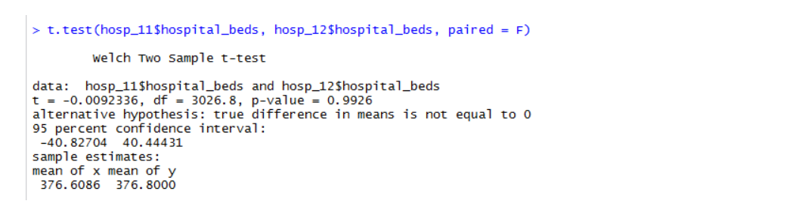

The p-value from above example, 0.9926, indicates that we DO NOT expect to see a meaningless (random) difference of 5% or more in ‘hospital beds’ only about 993 times in 1000 there is no difference (0.9926*1000=992.6 ~ 993).Note: This is an example from the week1 exercise.

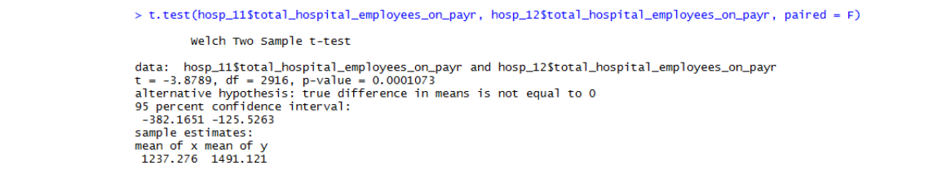

The p-value from above example, 0.0001, indicates that we’d expect to see a meaningless (random) ‘number of the employees on payer’ difference of 5% or more only about 0.1 times in 1000 (0.0001 * 1000=0.1). **CI around Difference**: A confidence interval around a difference that does not cross zero also indicates statistical significance. The graph below shows the 95% confidence interval around the difference between hospital beds in 2011 and 2012 (CI: [-40.82 ; 40.44]):

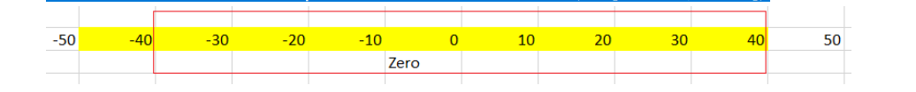

**CI around Difference:** A confidence interval around a difference that does not cross zero also indicates statistical significance. The graph below shows the 95% confidence interval around the difference between hospital beds in 2011 and 2012 (CI: [-382.16 ; 125.53]):



The boundaries of this confidence interval around the difference also provide a way to see what the upper [40.44] and lower bounds [-40.82].***As a summary:***“Statistically significant means a result is unlikely due to chance.The p-value is the probability of obtaining the difference we saw from a sample (or a larger one) if there really isn’t a difference for all users.Statistical significance doesn’t mean practical significance. Only by considering context can we determine whether a difference is practically significant; that is, whether it requires action.The confidence interval around the difference also indicates statistical significance if the interval does not cross zero. It also provides likely boundaries for any improvement to aide in determining if a difference really is noteworthy.With large sample sizes, you’re virtually certain to see statistically significant results, in such situations, it’s important to interpret the size of the difference”("Measuring U", 2019).*ResourceMeasuring U. (2019). Statistically significant. Retrieved May 17, 2019 from: [What Does Statistically Significant Mean?](https://measuringu.com/statistically-significant/) Small sample sizes often do not yield statistical significance; when they do, the differences themselves tend also to be practically significant; that is, meaningful enough to warrant action.

**4.Research Method**

Discuss the Research Methodology (in general). Describe the variable or variables that are being analyzed. Identify the statistical test you will select to analyze these data and explain why you chose this test.  Summarize your statistical alternative hypothesis. This section includes the following sub-sections:

***a)Describe the Dataset***

**Example:** The primary source of data will be HOSPITAL COMPARE MEDICARE DATA (citation). This dataset provides information on hospital characteristics, such as: Number of staffed beds, ownership, system membership, staffing by nurses and non-clinical staff, teaching status, percentage of discharge for Medicare and Medicaid patients, and information regarding the availability of specialty and high-tech services, as well as Electronic Medical Record (EMR) use (Describe dataset in 2-3 lines, Google the dataset and find the related website to find more information about the data).

Also, describe the sample size; for example, “The writer is using Medicare data-2013, this data includes 3000 obs. for all of the hospitals in the US.”

***b)Describe Variables***

Next, review the database you selected and select a variable or variables that are a “best-fit.”  That is, choose a variable that quantitatively measures the concept or concepts articulated in your research question or hypothesis.

Return to your previously stated Research Question or Hypothesis and evaluate it considering the variables you have selected. (See the sample Table 1).

**Table 1**. List of variables used for the analysis

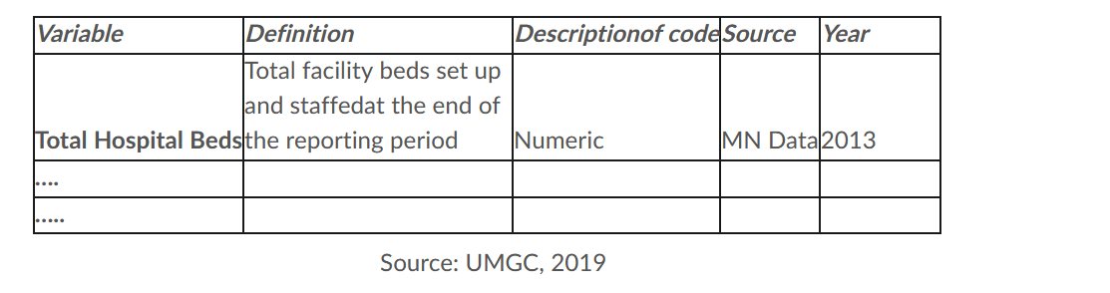

 ***Just in time information:

To cite a dataset, you can go with two approaches:**First**, look at the note in the dataset for example;Medicare National Data by County. (2012). Dartmouth Atlas of Health Care, A **Second**, use the online citation, for example:Zare, H., (2019, May). MN Hospital Report Data. Data posted in University of Maryland University College HMGT 400 online classroom, archived at: http://campus.umgc.edu

See two examples describing the variables from Minnesota Data:

**Table 2.** Definition of variables used in the analysis

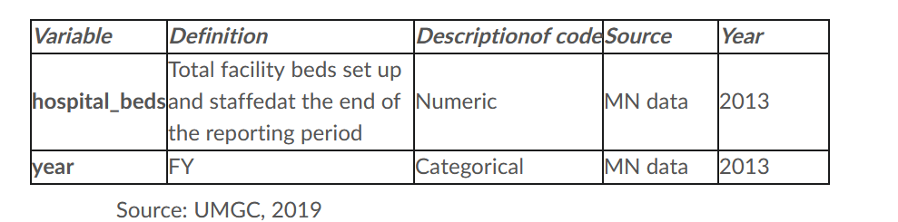

***c)Describe the Research Method for Analysis***

First, describe the research method as a general (e.g., this is a quantitative method and then explain about this method in about one paragraph. If you have this part in the introduction, you do not need to add here).

Then, explain the statistical method you plan to use for your analysis (Refer to content in week 3 on Biostatistics for information on various statistical methods you can choose from).

**Example:**

Hypothesis:  AZ hospitals are more likely to have lower readmission rates for PN compared to CA.

Research Method:  To determine whether Arizona hospitals are more likely to have lower readmission rate than California, we will use a t-test, to determine whether differences across hospital types are statistically significant (You can change the test depends on your analysis).

***d)Describe statistical package***

Add one paragraph for the statistical package, e.g., Excel or RStudio.

**5. Results**

Discuss your findings considering the following tips:

▪ Why you needed to see the distribution of data before any analysis (e.g., check for outliers, finding the best fit test; for example, if the data had not a normal distribution, you can’t use the parametric test, etc., so just add 1 or 2 sentences).

▪ Did you eliminate outliers? (Please write 1 or 2 sentences, if applicable).

▪ How many observations do you have in your database and how many for selected variables, report % of missing.

▪ When you are finished with this, go for the next steps:

Present the results of your statistical analysis; include any relevant statistical information (summary tables, including N, mean, std. dev.). Make sure to completely and correctly name all your columns and rows, tables and variables. For this part you could have at least 1-2 tables and 1-2 figures (depending on your variables bar-chart, pi-chart, or scatter-plot), you can use a table like this:

**Table 3.** Descriptive analysis to compare % of BL in Medicare beneficiary, MD vs. VA- 2013

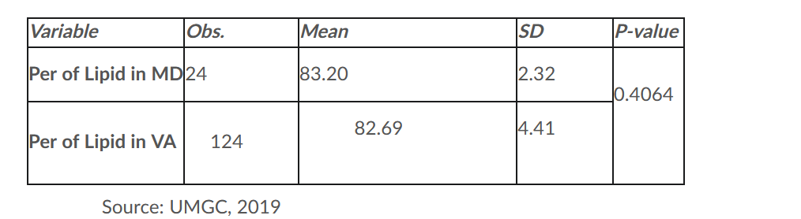

When you have tables and plots ready, think about your finding and **state the statistical conclusion**.  That is, do the results present evidence in favor or the null hypothesis or evidence that contradicts the null hypothesis?

**6.Conclusion and Discussion**

Review your research questions or hypothesis.

How has your analysis informed this question or hypothesis?  Present your conclusion(s) from the results (presented above) and discuss the meaning of this conclusion(s) considering the research question or hypothesis presented in your introduction.

At the end of this section, add one or two sentences and discuss the limitations (including biases) associated with this analysis and any other statements you think are important in understanding the results of this analysis.

|  |  |
| --- | --- |
| **References**  Include a reference page listing the bibliographic information for all sources cited in this report. This information should be consistent with the requirements specified in the American Psychological Association (APA) format and style guide. | |
|  |  |
| Due on Aug 26, 2025 11:59 PM | |